**AMS LAB1: Simulation of a Capcitor’s VTC**

**Aim:** To simulate the VTC of a capacitor with a constant current source and a supply voltage of constant 2V DC.

**Calculations:**

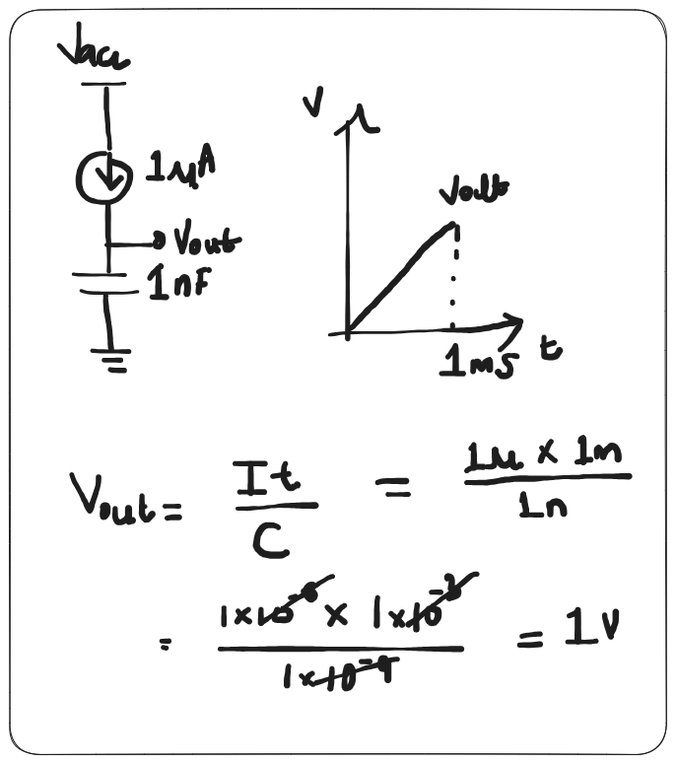

**Simulation procedure:** Transient analysis at node vout was done which was between the cc source and the capacitor's positive terminal.

**Schematic:**

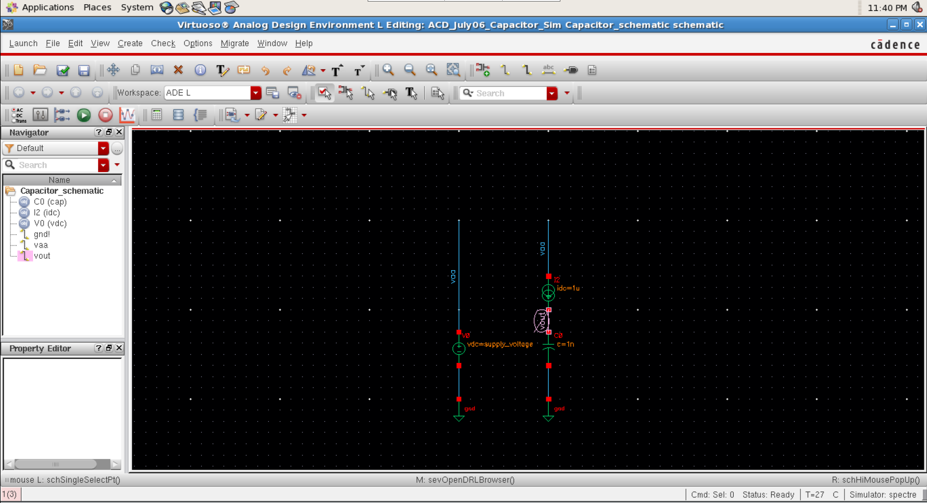

**Netlists:**

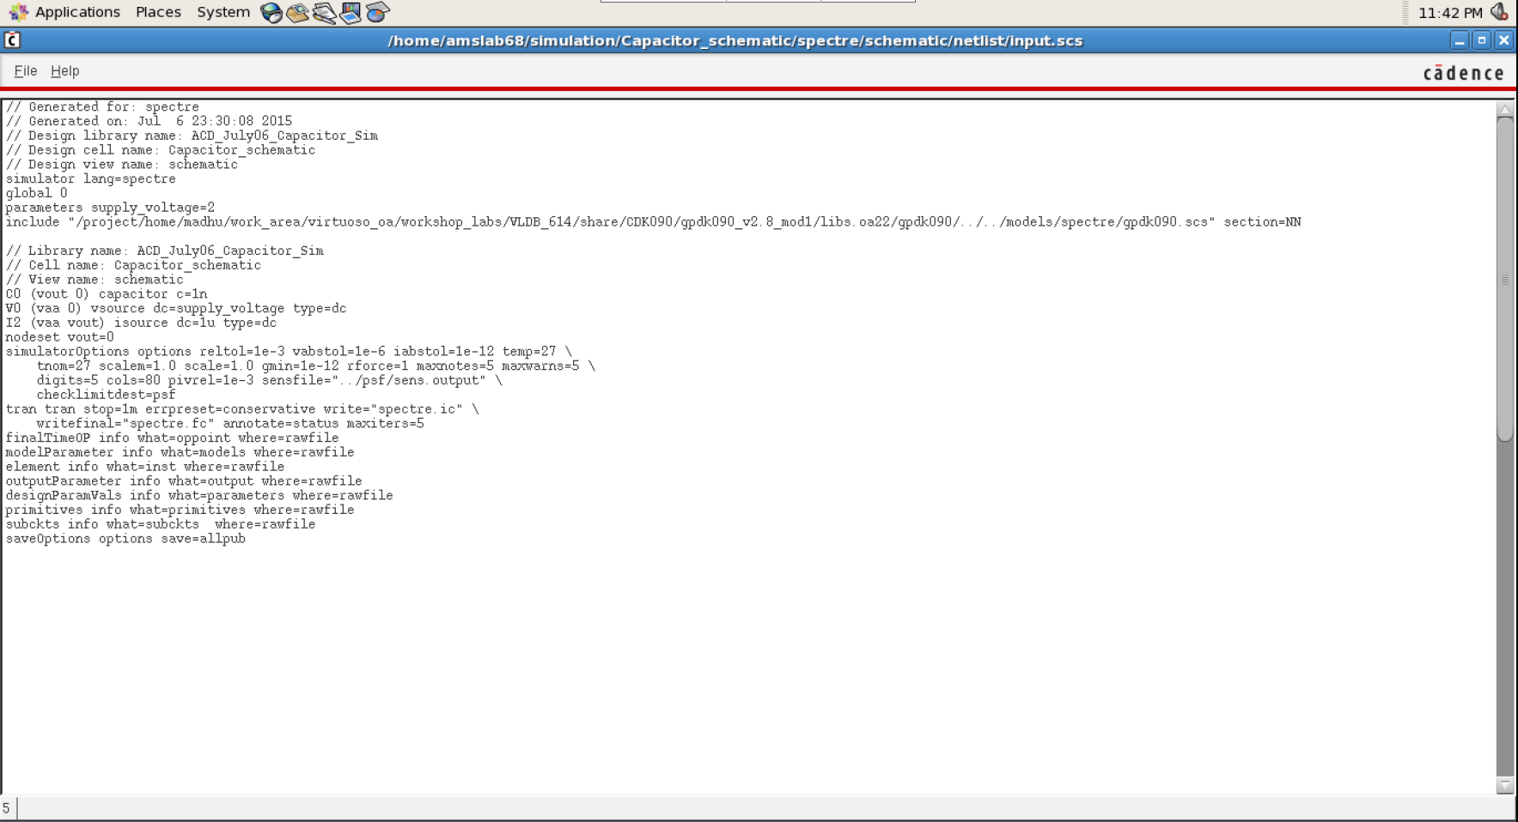

**Analyses:**

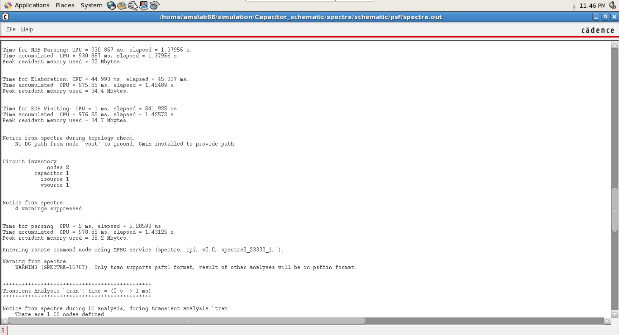

**DC:**

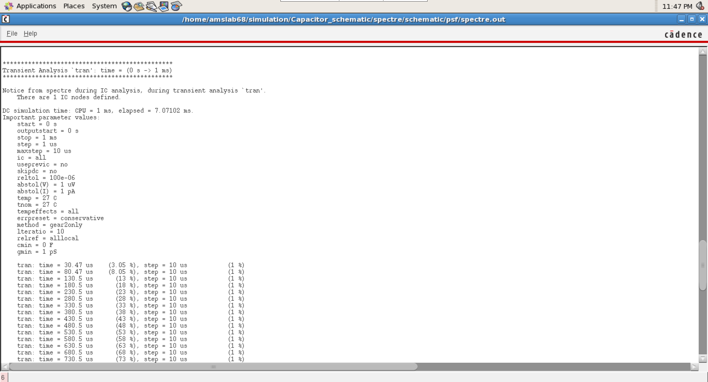

**AC Transient:**

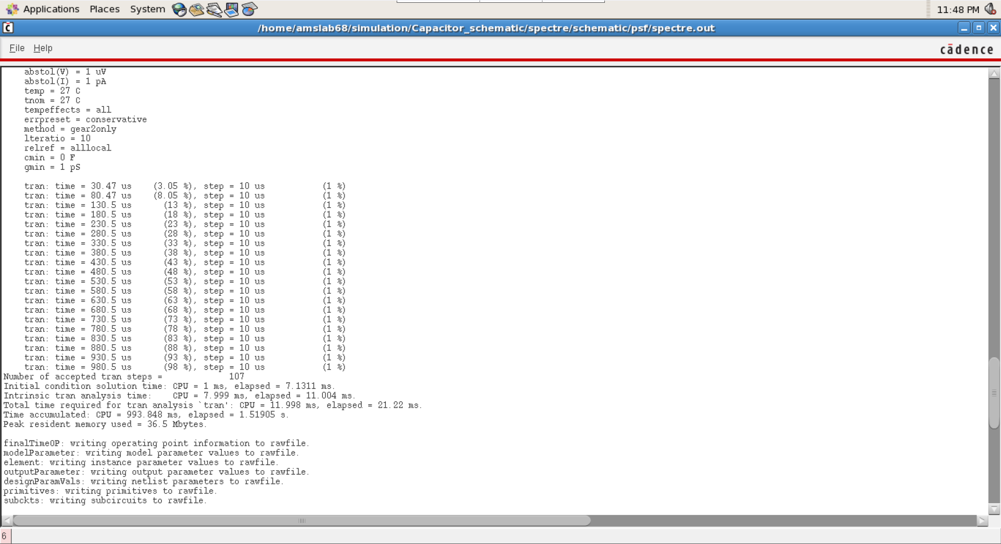

**VTC Graph:**

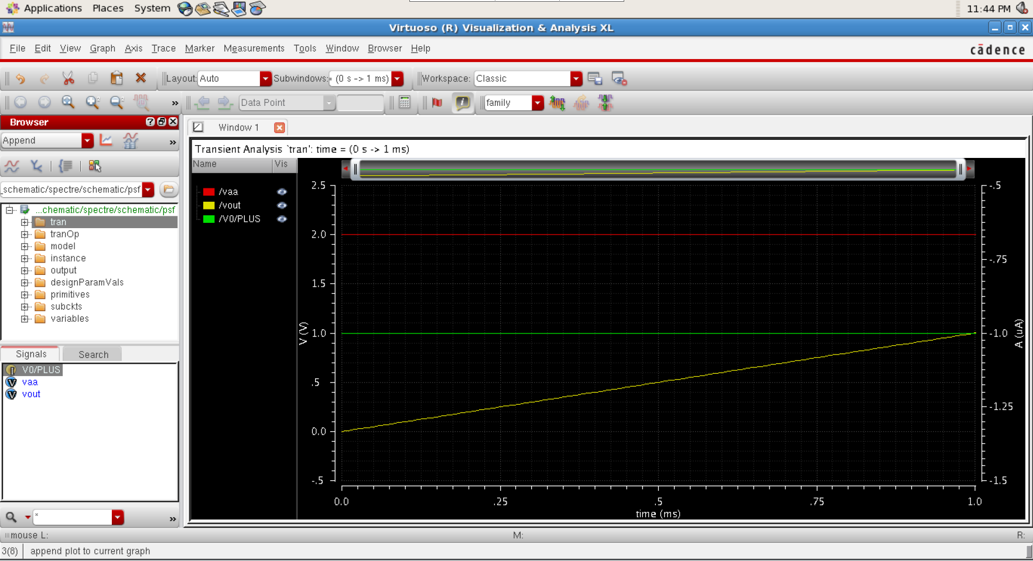

**Results:**

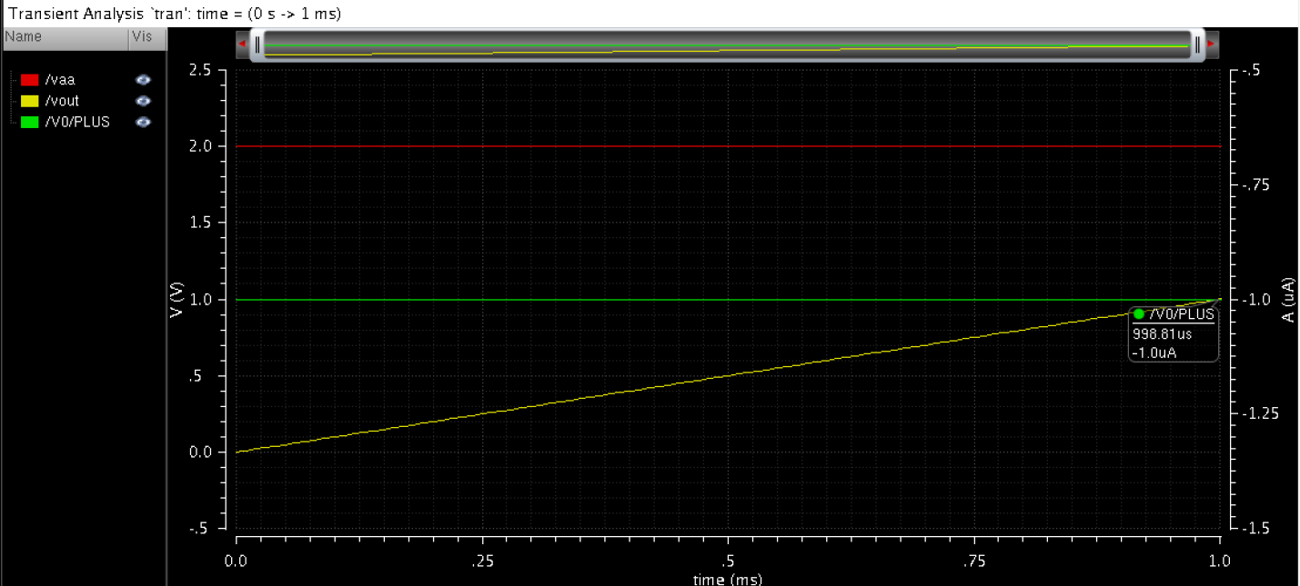

**Conclusion:** As calculated in theory, the practical simulation results were the same, that is after a transient analysis of 1ms delay, the capacitor charges linearly until it reaches the 1V mark.